### 1. What will be the output of the following code?

var i = 0;  
for (i = 0; i < 3; i++) {  
 console.log(i);  
}

1. 0 1 2 guess [correct]
2. 1 2 3
3. 0 1 2 3
4. 1 2

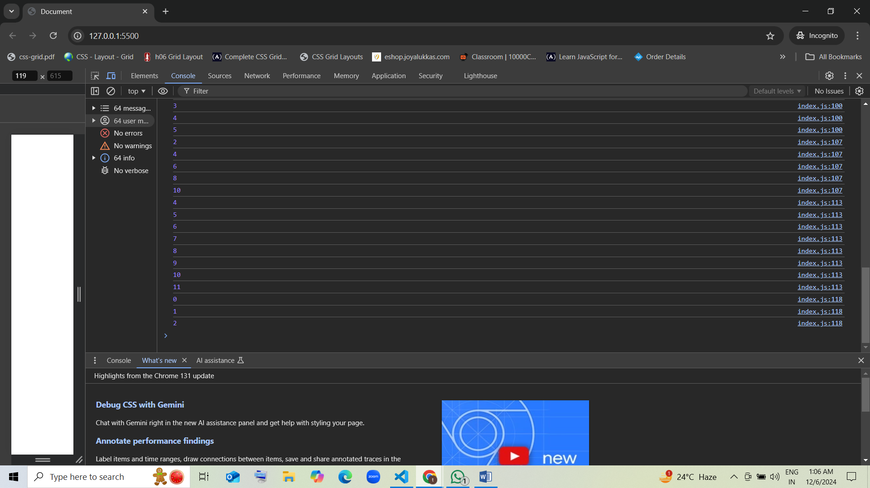

### 2. What will the following code output?

var i = 0;  
while (i < 2) {  
 console.log(i);  
 i++;  
}

1. 1 2
2. 0 1 guess [correct]
3. 0 1 2
4. 1 2 3

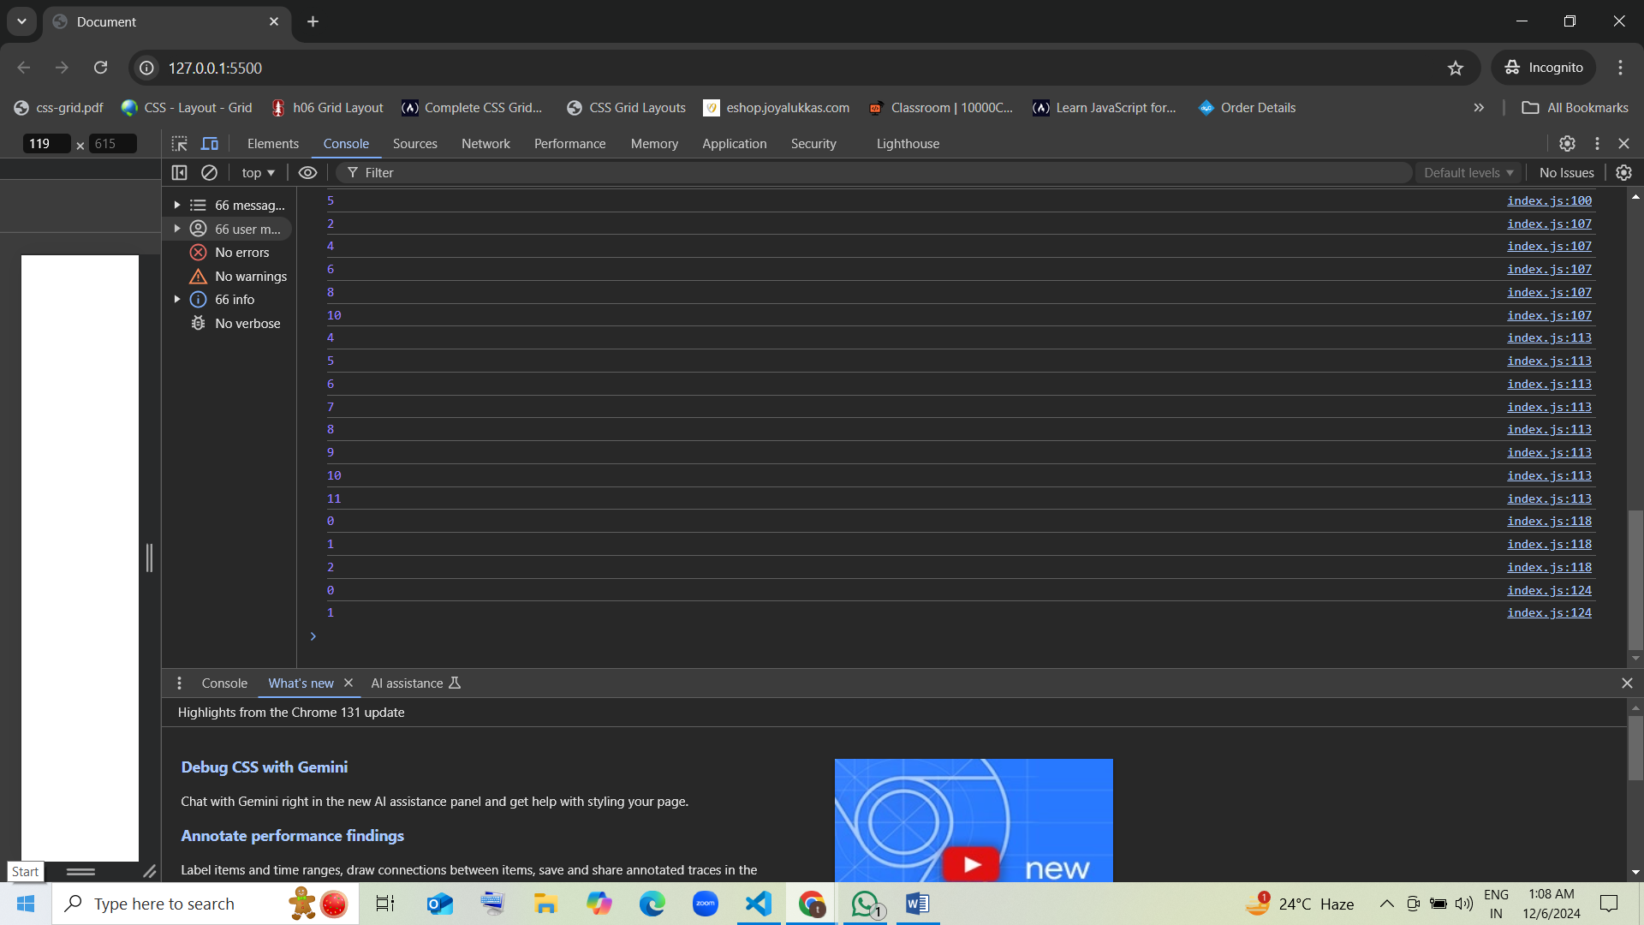

### 3. How many times will the loop execute?

var i = 0;  
while (i < 5) {  
 i++;  
}

1. 0
2. 1
3. 4
4. 5 guess [correct]

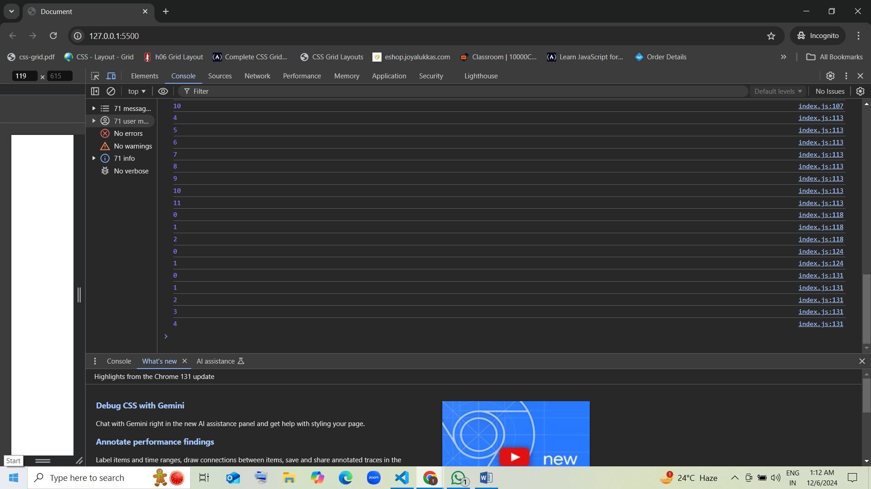

### 4. What will this code print?

for (var i = 0; i <= 3; i++) {  
 console.log(i);  
}

1. 0 1 2 3 guess [correct]
2. 1 2 3
3. 1 2
4. 0 1 2 3 4

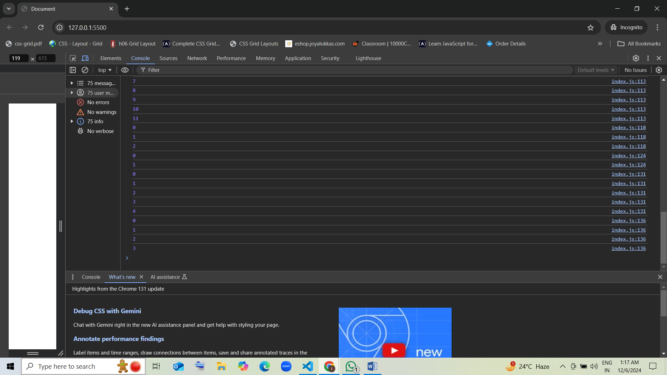

### 5. What is the output of this code?

var i = 0;  
do {  
 console.log(i);  
 i++;  
} while (i < 3);

1. 0 1 2 guess [correct]
2. 1 2 3
3. 0 1 2 3
4. 1 2

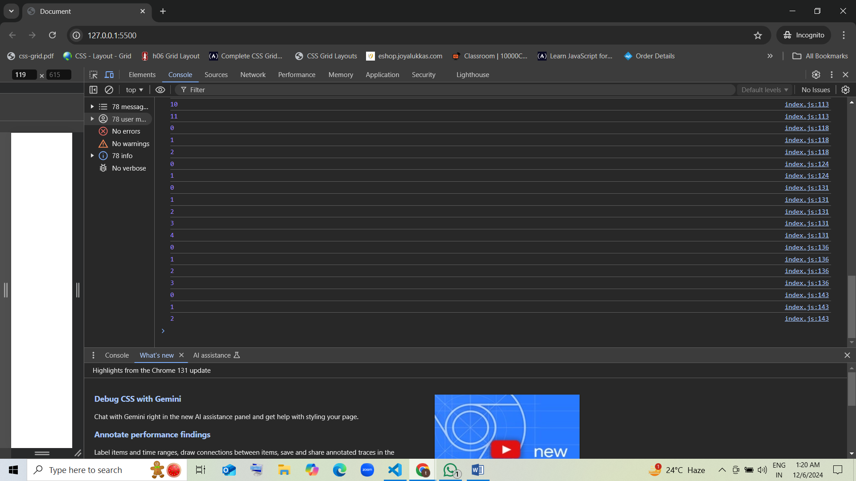

### 6. How many times will the following code execute?

var i = 0;  
do {  
 i++;  
} while (i < 10);

1. 9
2. 10 [correct]
3. Infinite
4. 0

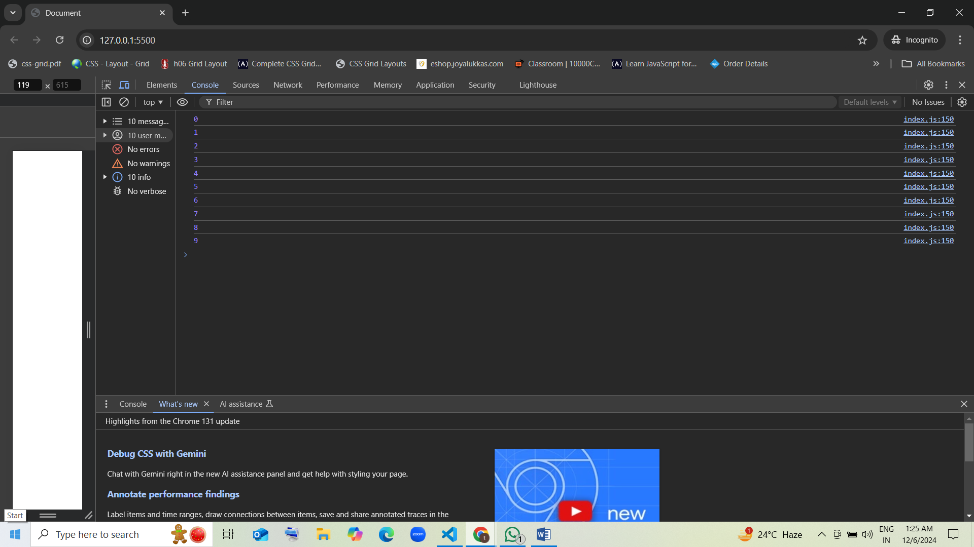

### 7. What will be printed by this code?

var i = 3;  
while (i > 0) {  
 console.log(i);  
 i--;  
}

1. 3 2 1 guess [correct]
2. 1 2 3
3. 2 1 0
4. 3 2

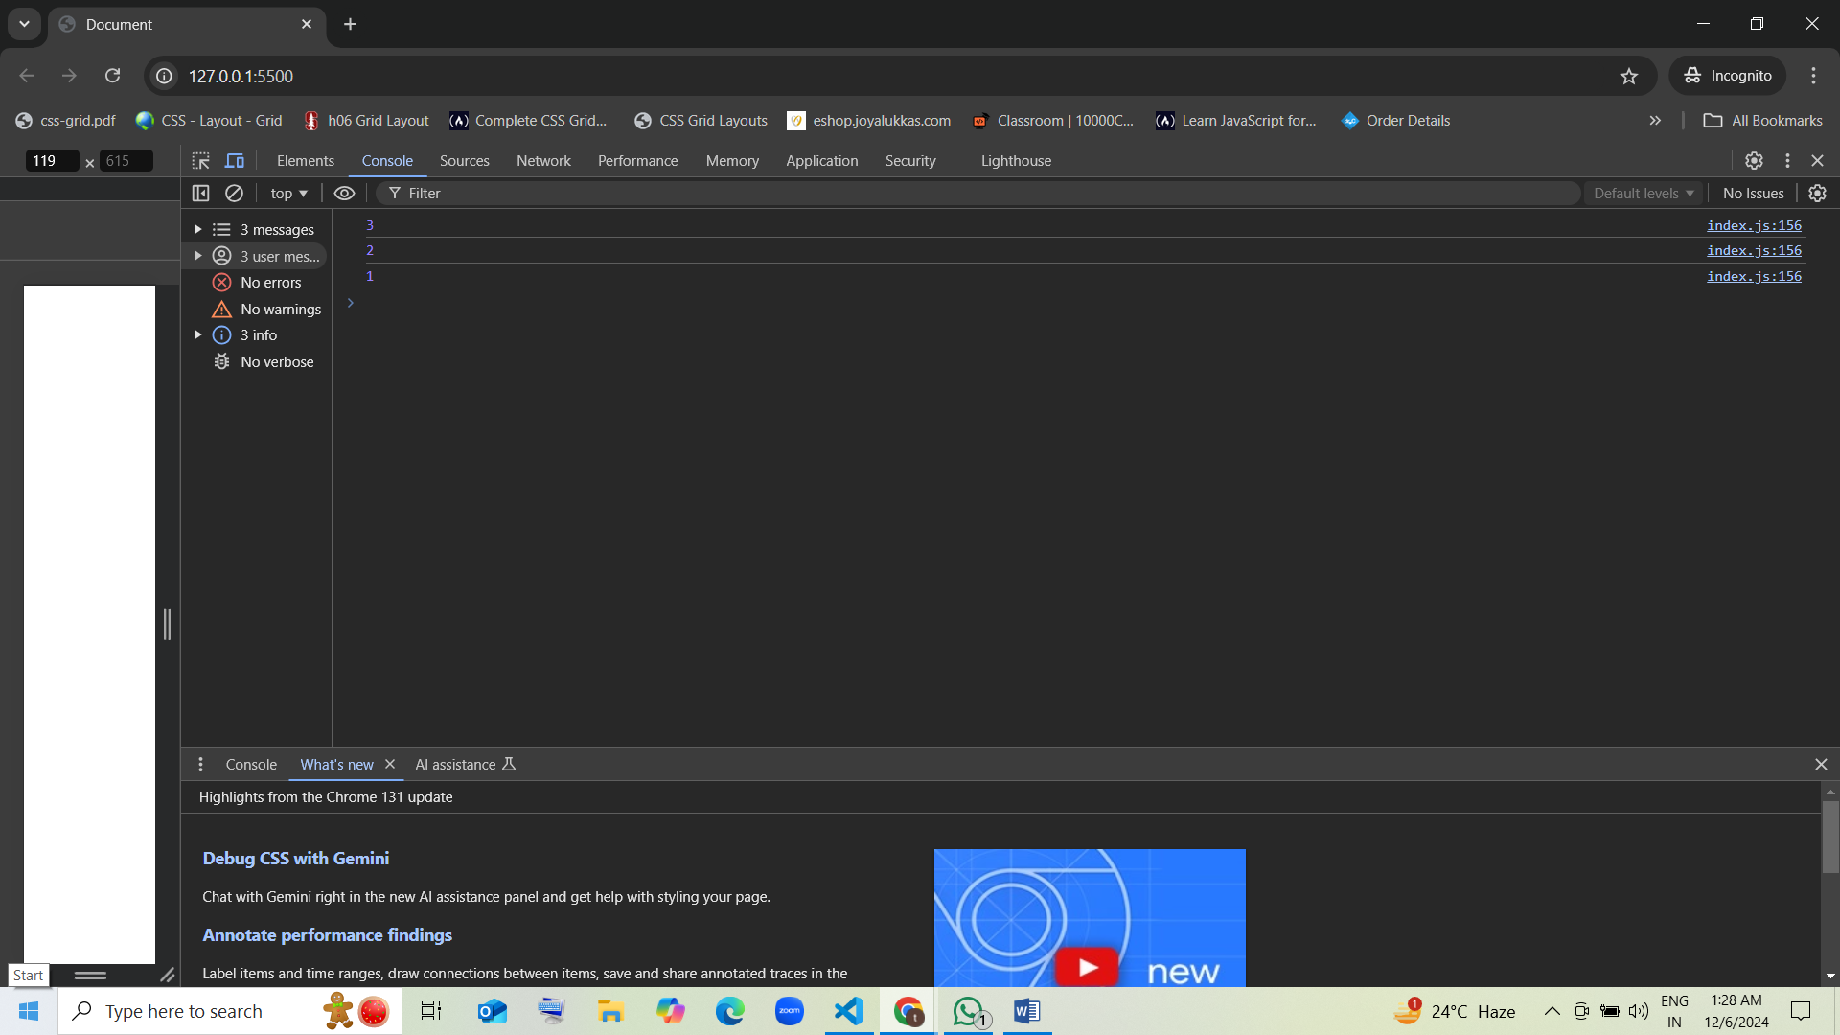

### 8. What is the result of the following code?

var i = 0;  
for (; i < 3;) {  
 console.log(i);  
 i++;  
}

1. 0 1 2 guess [correct]
2. 0 1
3. 1 2 3
4. 1 2

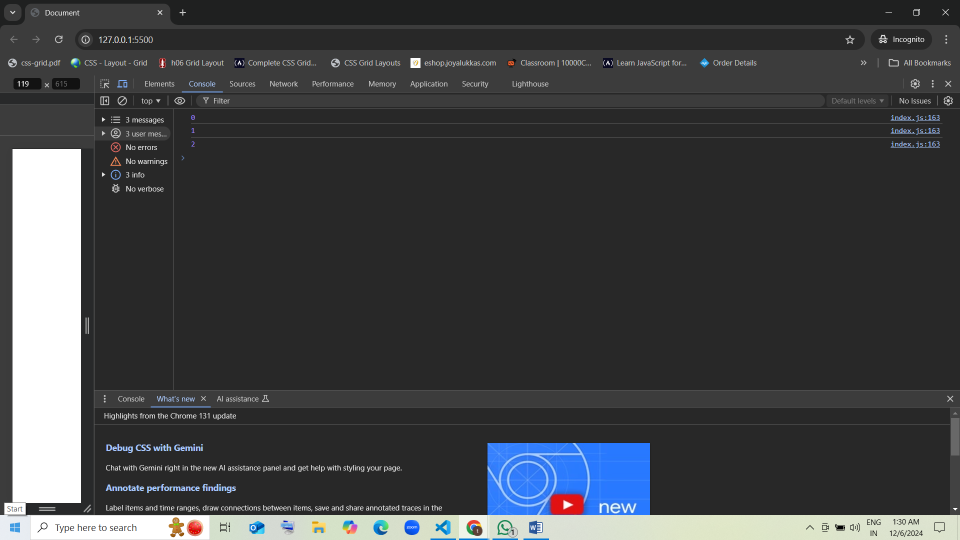

### 9. What will this code print?

var i = 1;  
do {  
 console.log(i);  
 i++;  
} while (i < 4);

1. 1 2 3 guess [correct]
2. 2 3 4
3. 0 1 2
4. 0 1

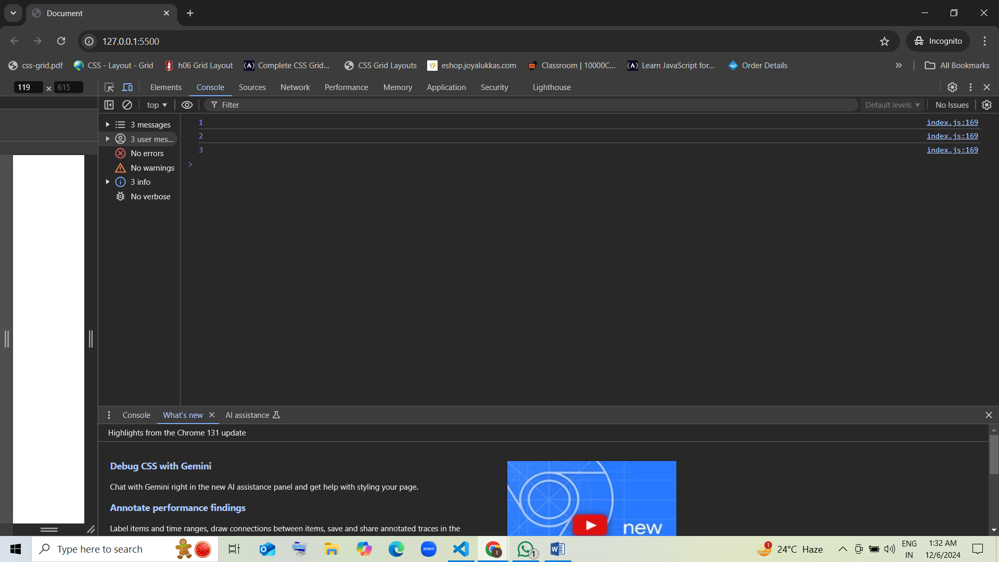

### 10. What will be the output of the following code?

var i = 0;  
for (i = 0; i < 5; i++) {  
 if (i == 2) {  
 break;  
 }  
 console.log(i);  
}

1. 0 1 guess [correct]
2. 1 2
3. 0 1 2
4. 2 3 4

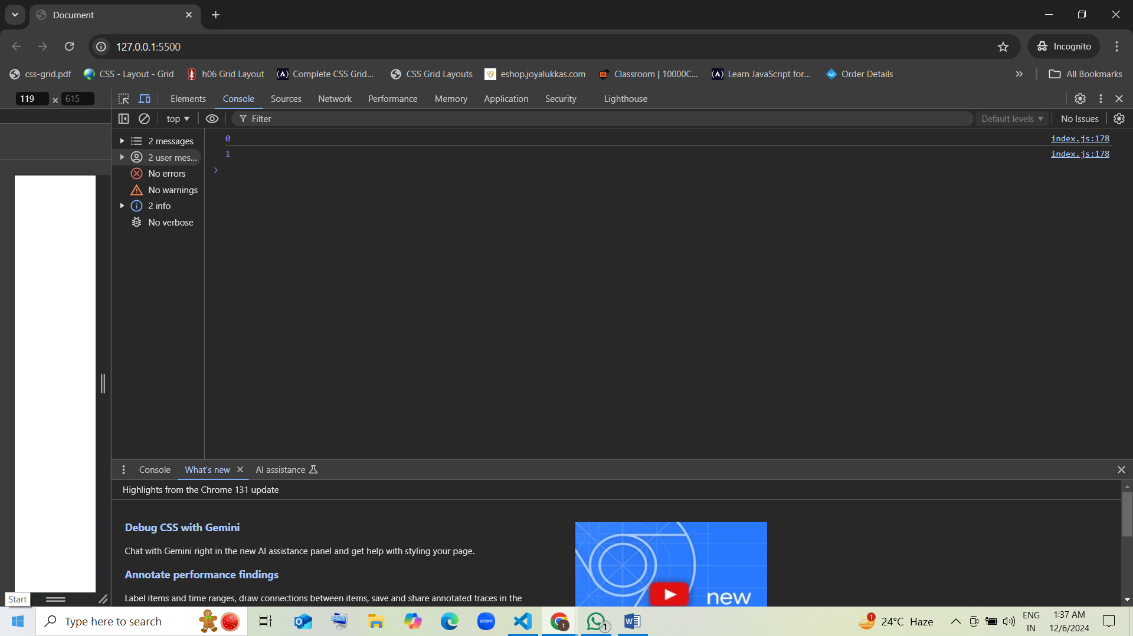

### 11. How many iterations will the following loop perform?

var i = 5;  
while (i <= 5) {  
 i++;  
}

1. Infinite
2. 5 guess [correct]
3. 1
4. 0

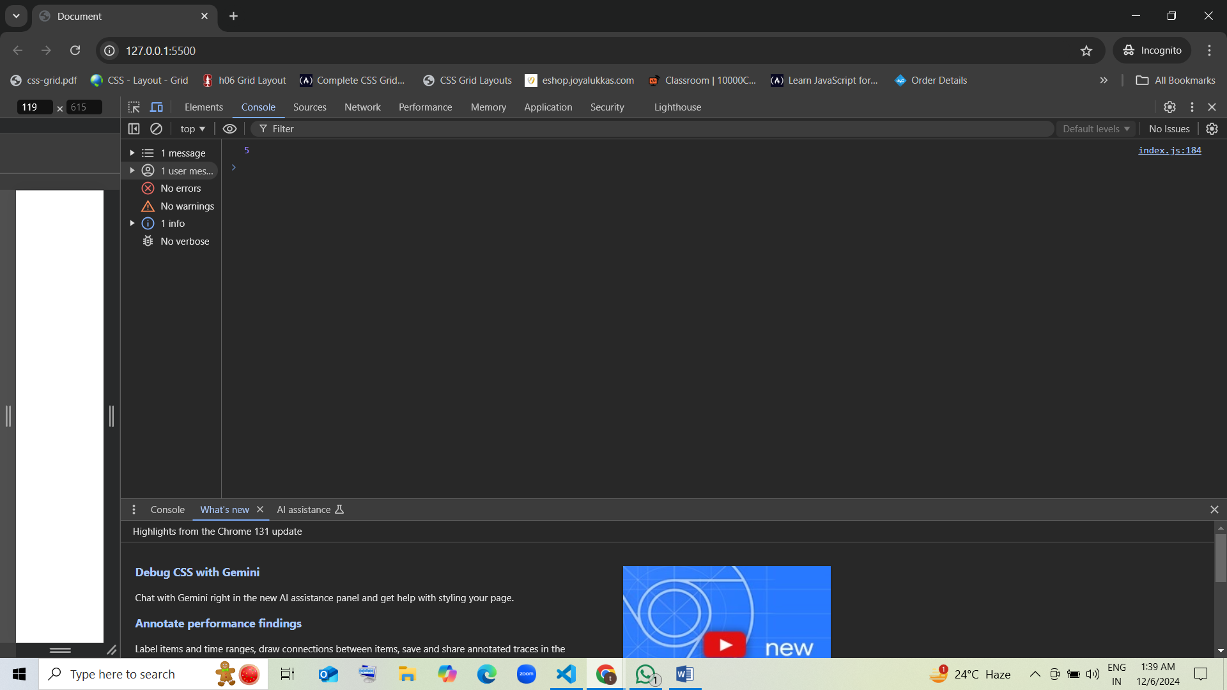

### 12. What will this code print?

var i = 0;  
for (var j = 0; j < 2; j++) {  
 i++;  
}  
console.log(i);

1. 0
2. 1 guess
3. 2 [correct ]
4. 3

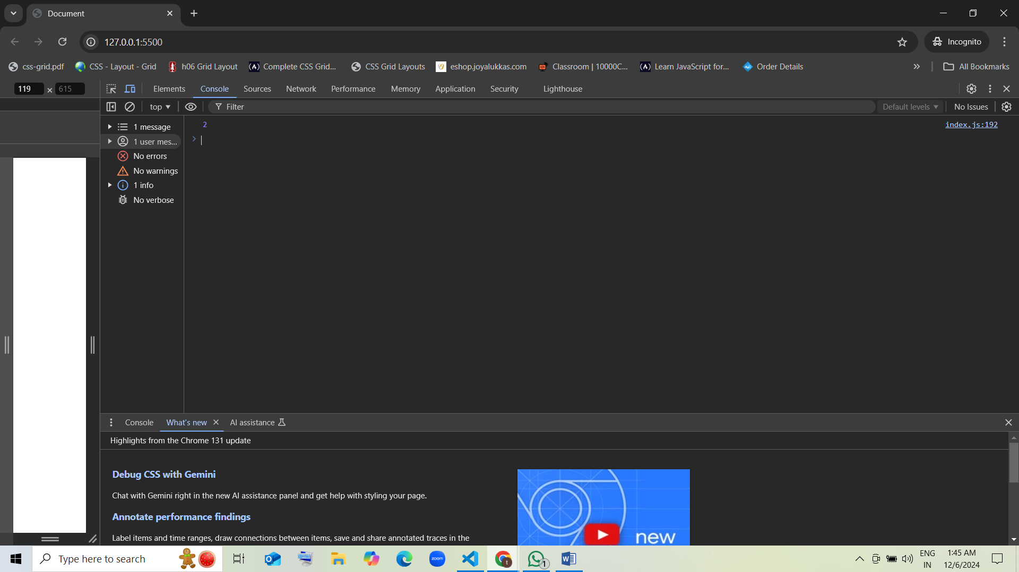

### 13. What will be the result of the following code?

var i = 0;  
do {  
 console.log(i);  
 i++;  
} while (i < 0);  
console.log(i);

1. 0
2. 1 guess [correct]
3. -1
4. Infinite

Ans: 0

1

1. 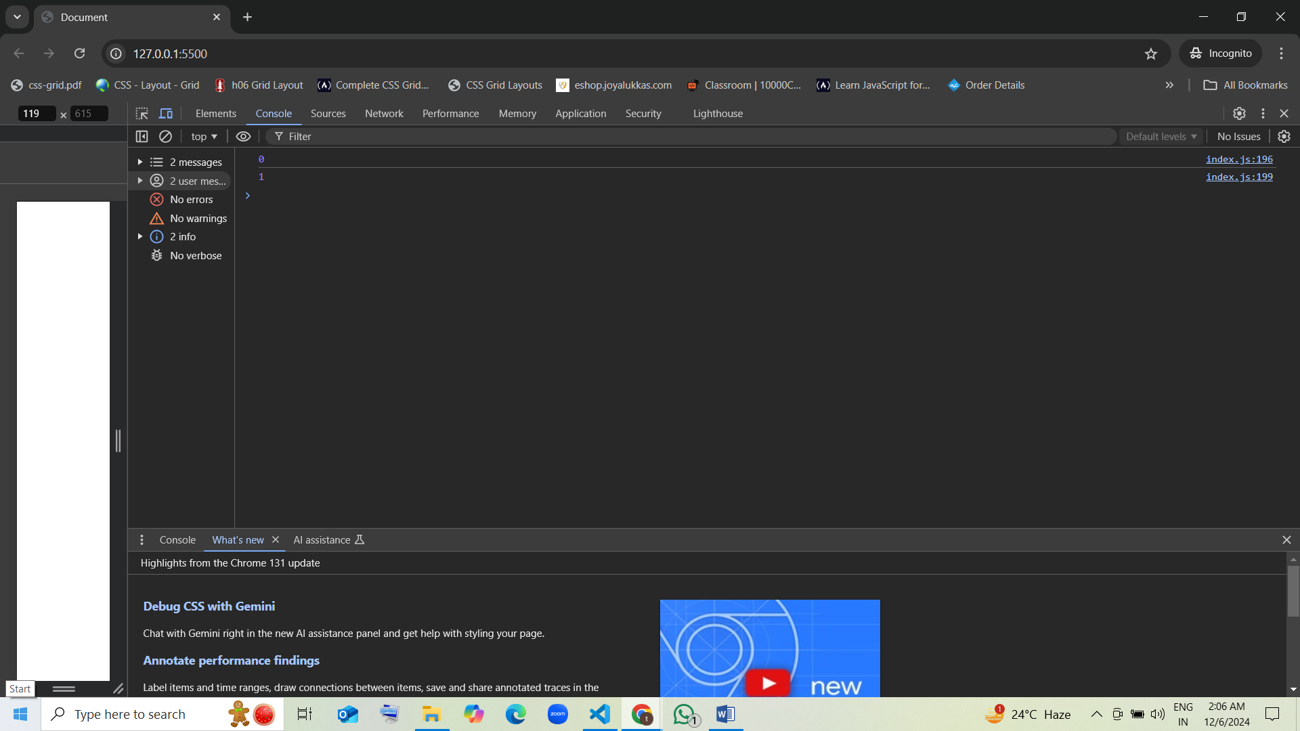

### 14. What does the following code output?

for (var i = 0; i < 5; i++) {  
 if (i === 3) continue;  
 console.log(i);  
}

1. 0 1 2 3 4 guess [correct]
2. 0 1 2 4
3. 0 1 3 4
4. 1 2 3 4

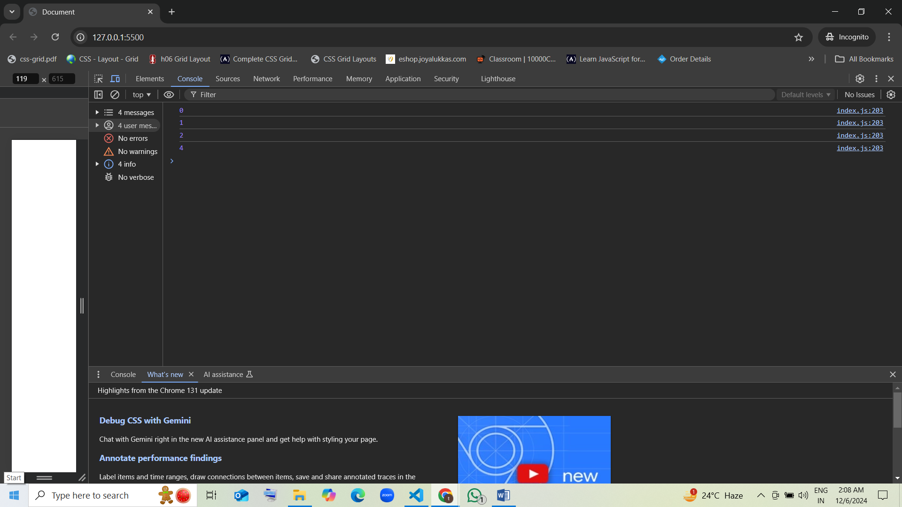

### 15. How many times will the following loop run?

var i = 1;  
for (i = 0; i < 10; i++) {  
 if (i == 5) break;  
}

1. 5 guess [correct]
2. 4
3. 10
4. Infinite

Ans:

0

1

2

3

4

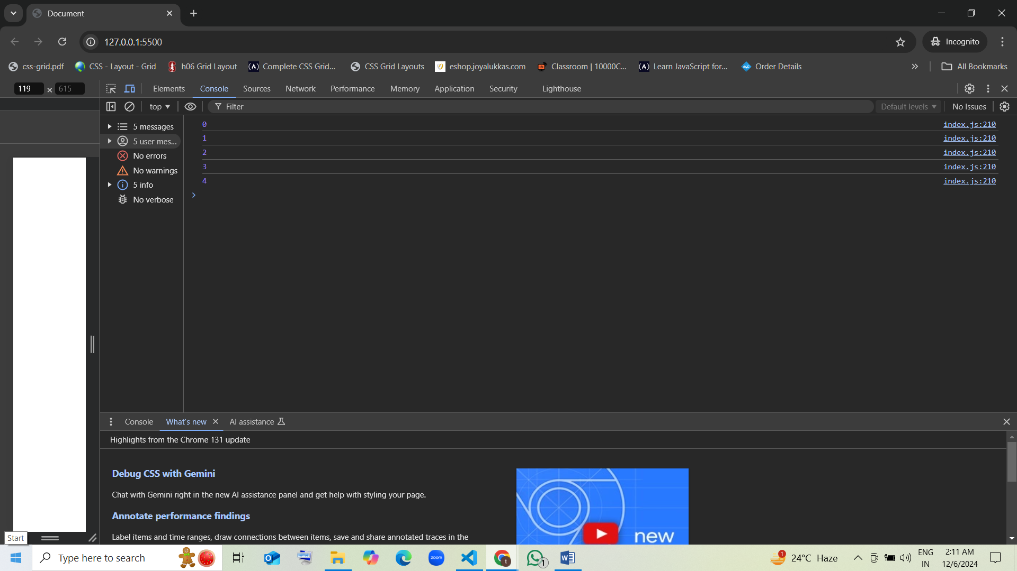

### 16. What will the following loop output?

var i = 0; 0 1  
for (var j = 0; j < 2; j++) {  
 i++; 1 2  
 console.log(i); 1 2  
}

1. 0 1
2. 1 2 guess [correct]
3. 0 2
4. 1 1

### 17. What is the output of this code?

var i = 0;1 2 3  
while (i < 4) { 0 1 2 3  
 console.log(i++); 1 2 3 4  
}

1. 0 1 2 3 guess [correct]
2. 1 2 3 4
3. 0 1 2
4. 1 2 3

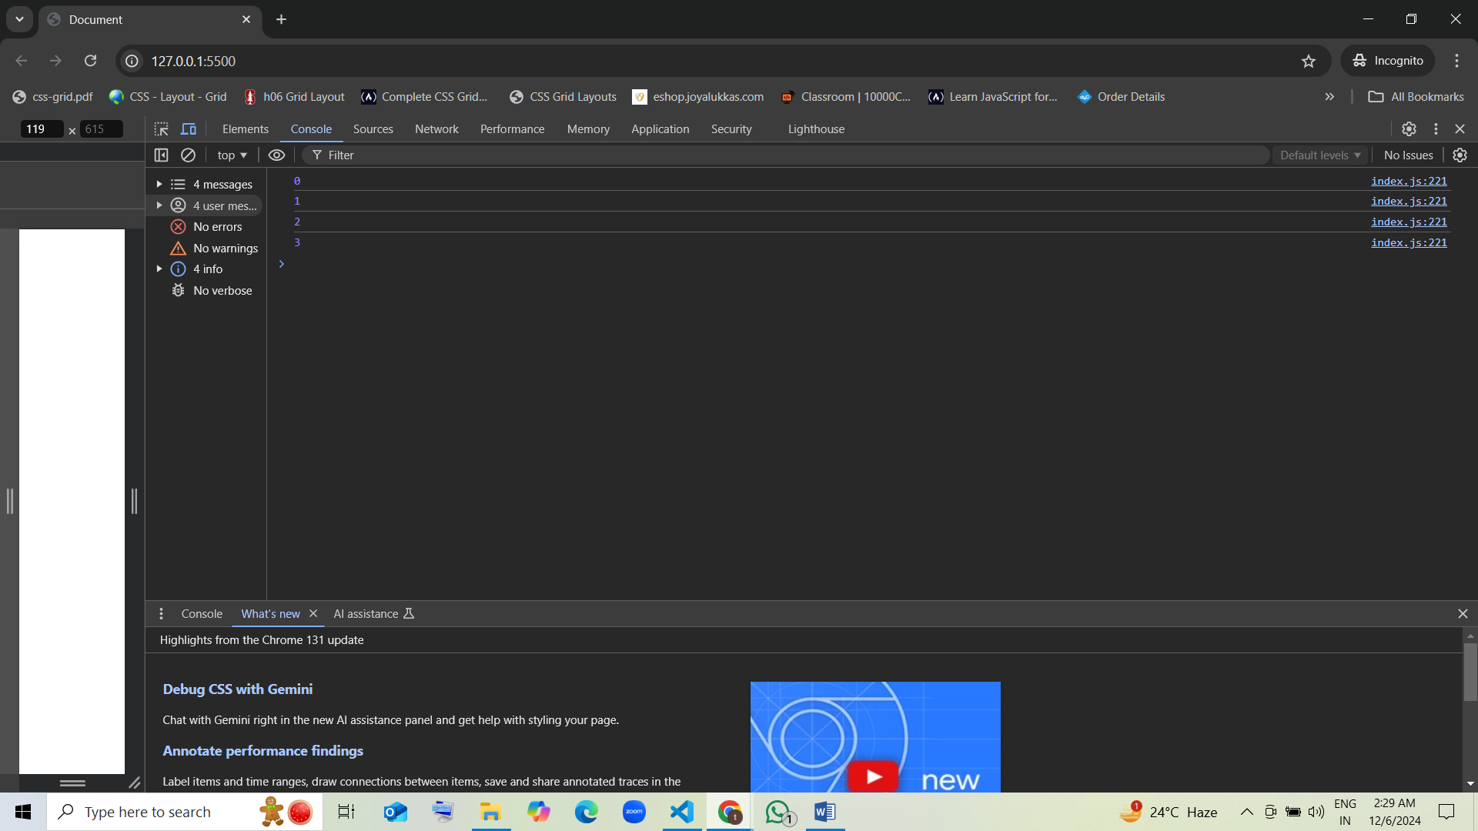

### 18. What is the result of the following code?

var i = 1;  
do {  
 console.log(i);  
 i++;  
} while (i <= 5);

1. 1 2 3 4 5 guess [correct]
2. 1 2 3 4
3. 0 1 2 3 4
4. 2 3 4 5

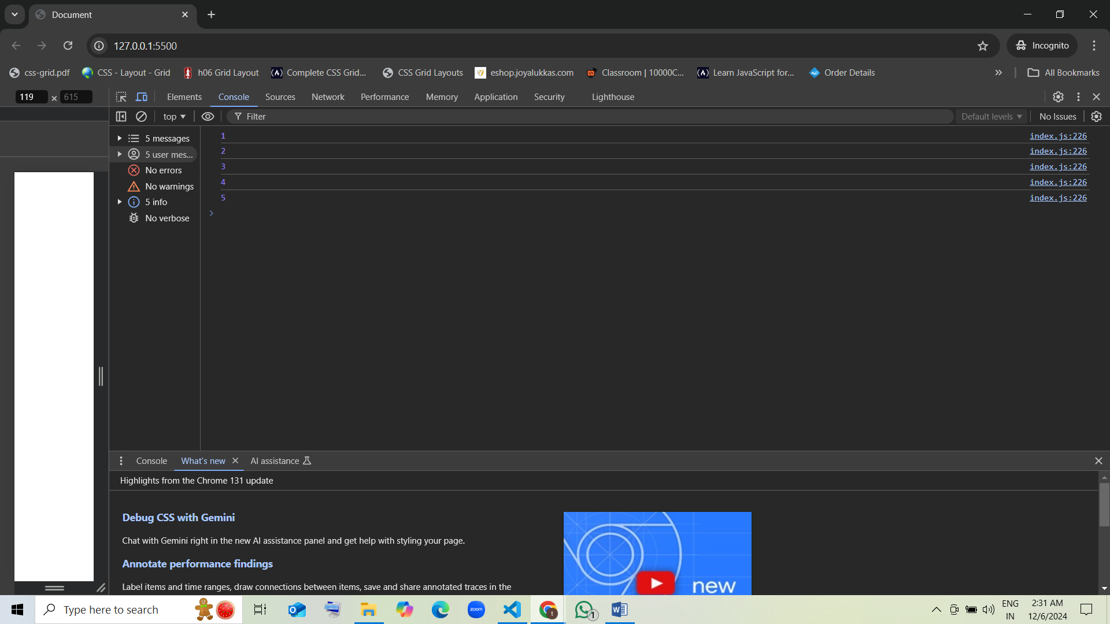

### 19. How many times will the following loop print?

var i = 0;  
for (i = 0; i < 3; i++) {  
 console.log(i);  
}

1. 3 guess [correct]
2. 4
3. 2
4. 5

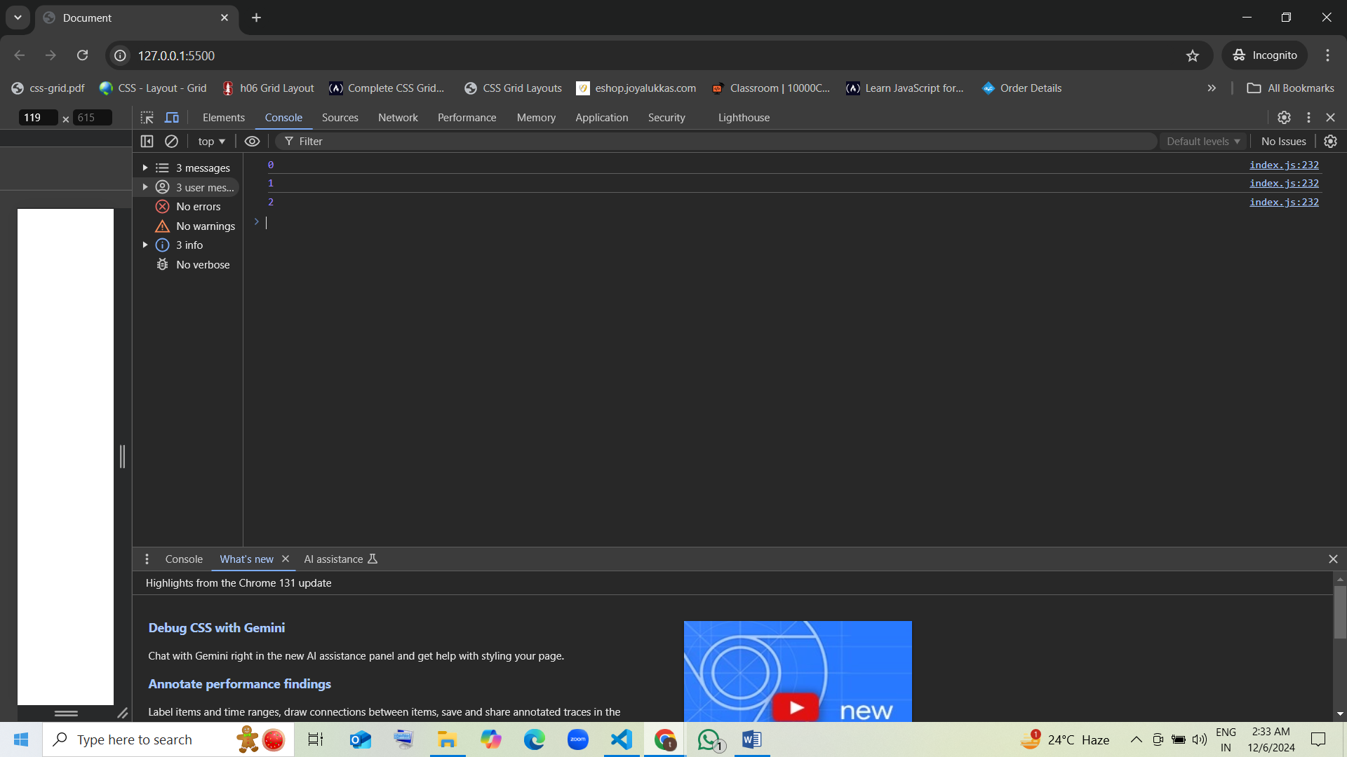

### 20. What will be printed?

var i = 0;  
do {  
 console.log(i);  
 i++;  
} while (i < 2);

1. 0 1 guess [correct]
2. 1 2
3. 0 1 2
4. 1 2 3

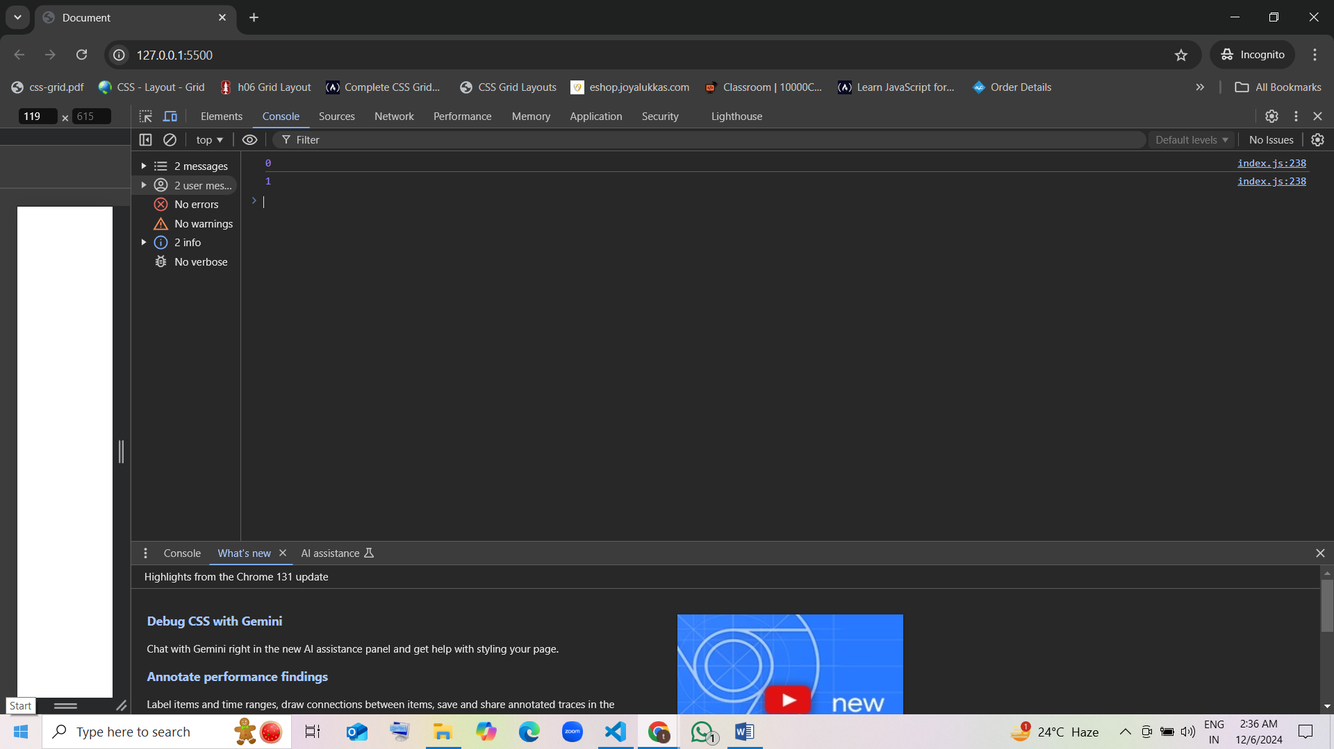

### 21. What is the result of the following code?

var i = 3; 4   
while (i < 5) {  
 i++; 4 5  
 console.log(i); 4 5  
}

1. 3 4 5
2. 4 5 guess [correct]
3. 5 6
4. 4

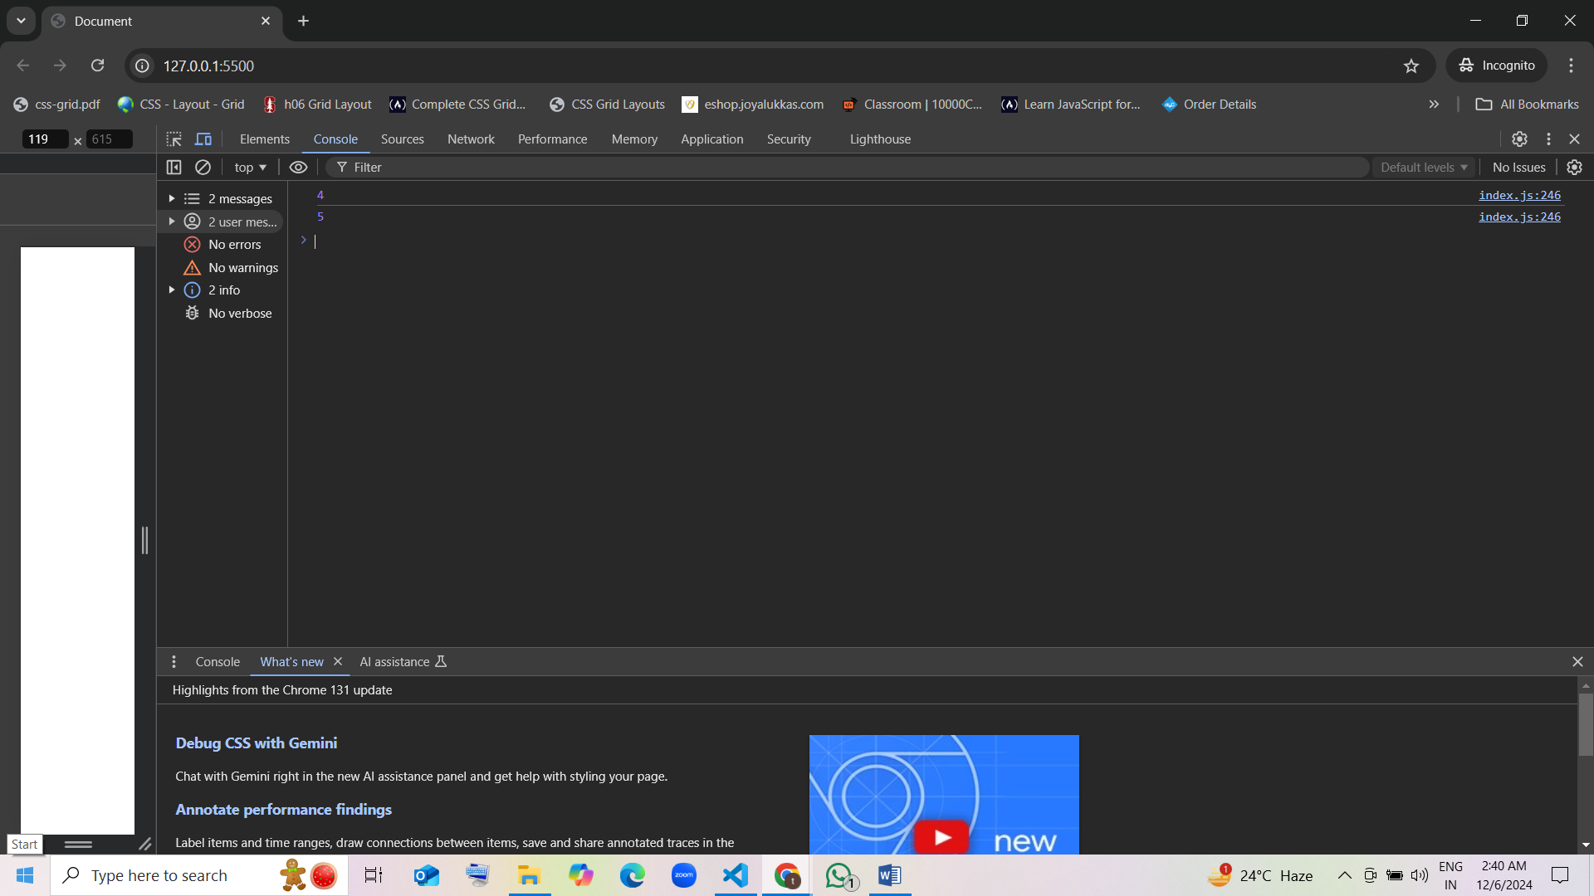

### 22. What is the output of this code?

var i = 0; 1 2 3  
for (; i < 4;) {  
 i++;  
 console.log(i); 1 2 3 4  
}

1. 1 2 3 4 guess [correct]
2. 0 1 2 3
3. 1 2 3
4. 1 2

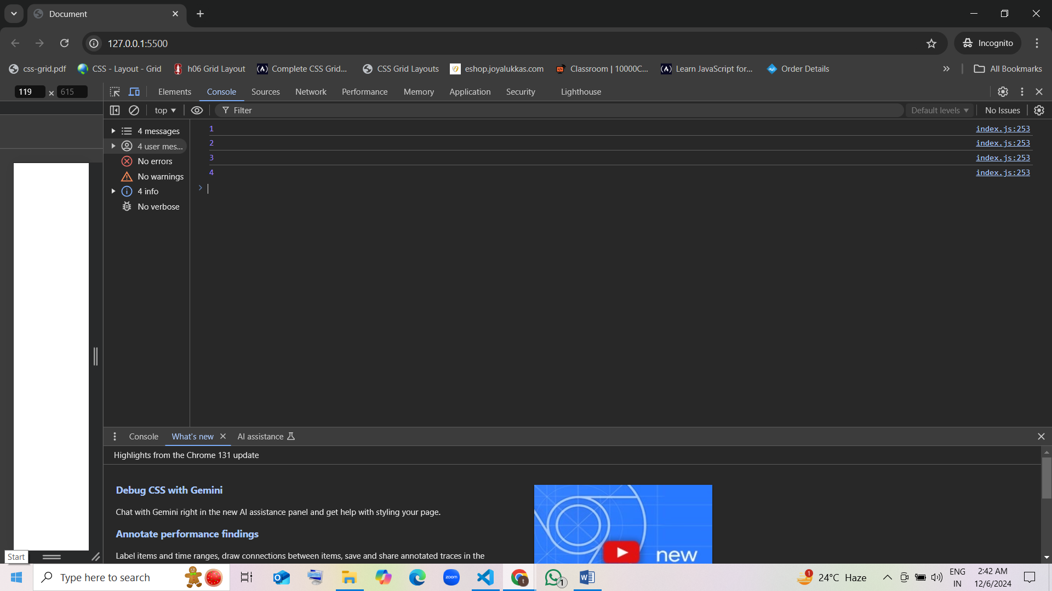

### 23. How many times will this loop run?

var i = 0; 1 2 3 4 5 6 7 8 9  
while (i < 10) {  
 i++;   
 if (i == 5) continue; 1 2 3 4 5 6 7 8 9 10  
}

1. 9
2. 10 guess [correct]
3. Infinite
4. 5

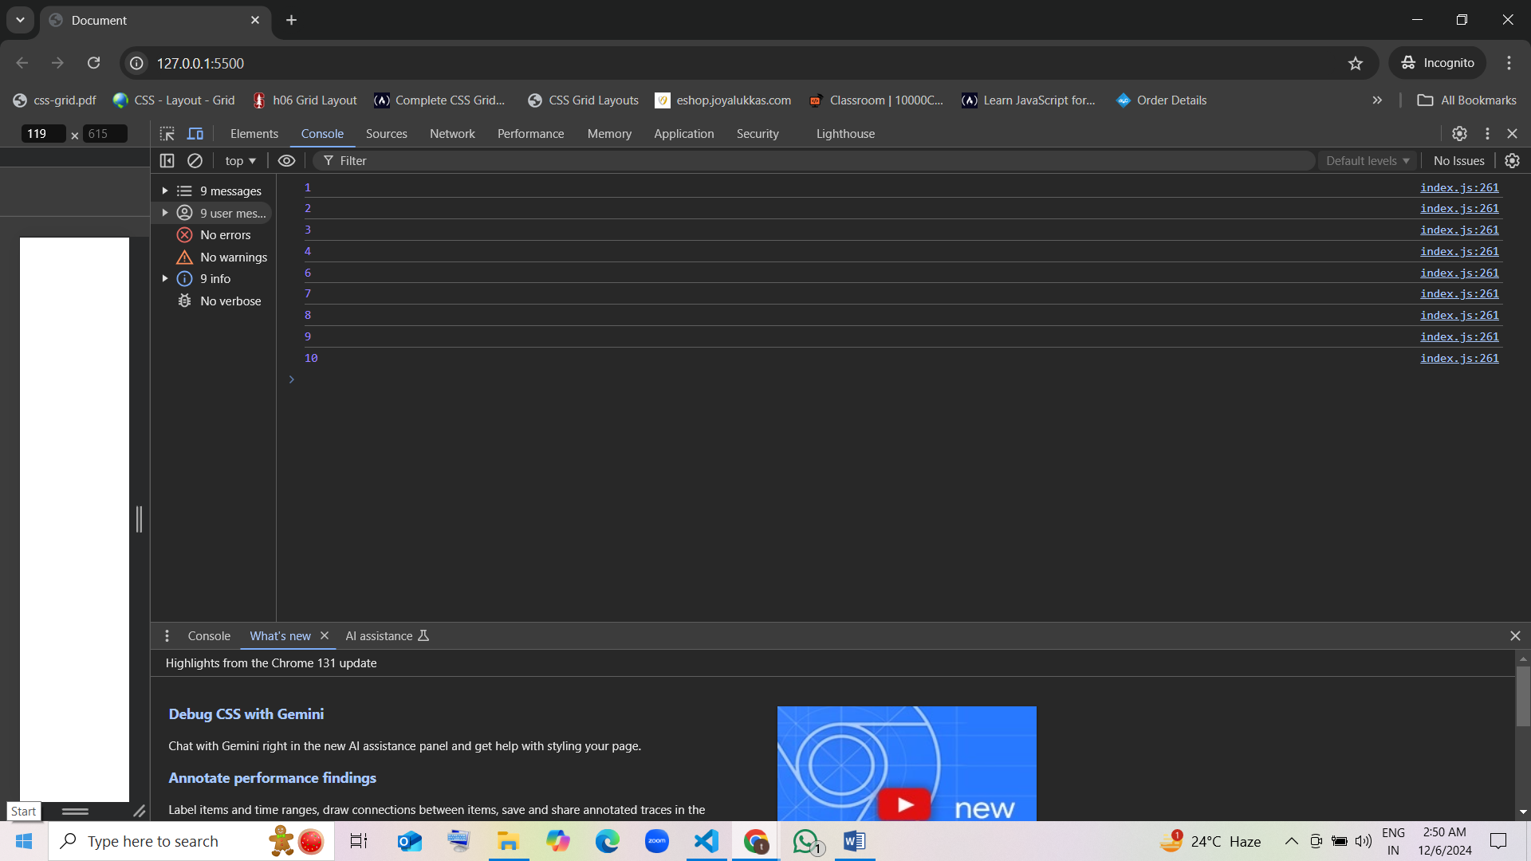

### 24. What will the following code output?

var i = 0;  
do {  
 if (i === 2) break;  
 console.log(i); 0 1  
 i++; 1 2  
} while (i < 5);

1. 0 1 guess [correct]
2. 0 1 2
3. 1 2 3
4. 0 1 2 3 4

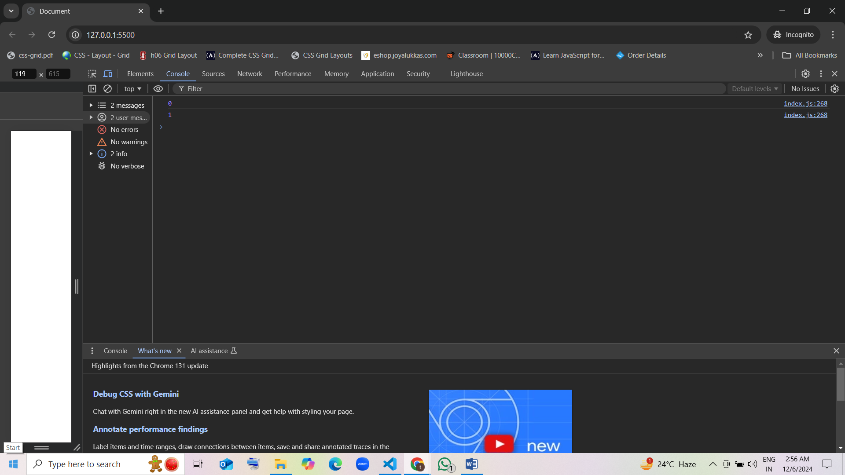

### 25. What will be printed by this code?

for (var i = 0; i < 4; i++) { 1 2  
 if (i === 2) continue;  
 console.log(i); 0 1 3  
}

1. 0 1 3 [correct]
2. 1 2 3
3. 0 1
4. 0 1 2

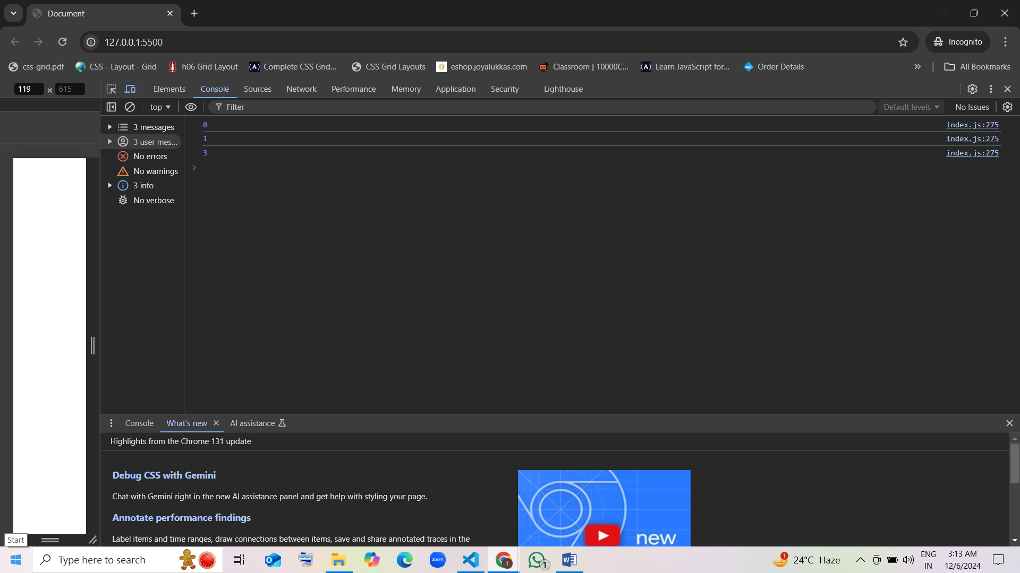

### 26. How many times will the following loop execute?

var i = 0;  
do {  
 console.log(i); 0 1 2   
 i++;  
} while (i < 3);

1. 3 guess [correct]
2. 4
3. 2
4. Infinite

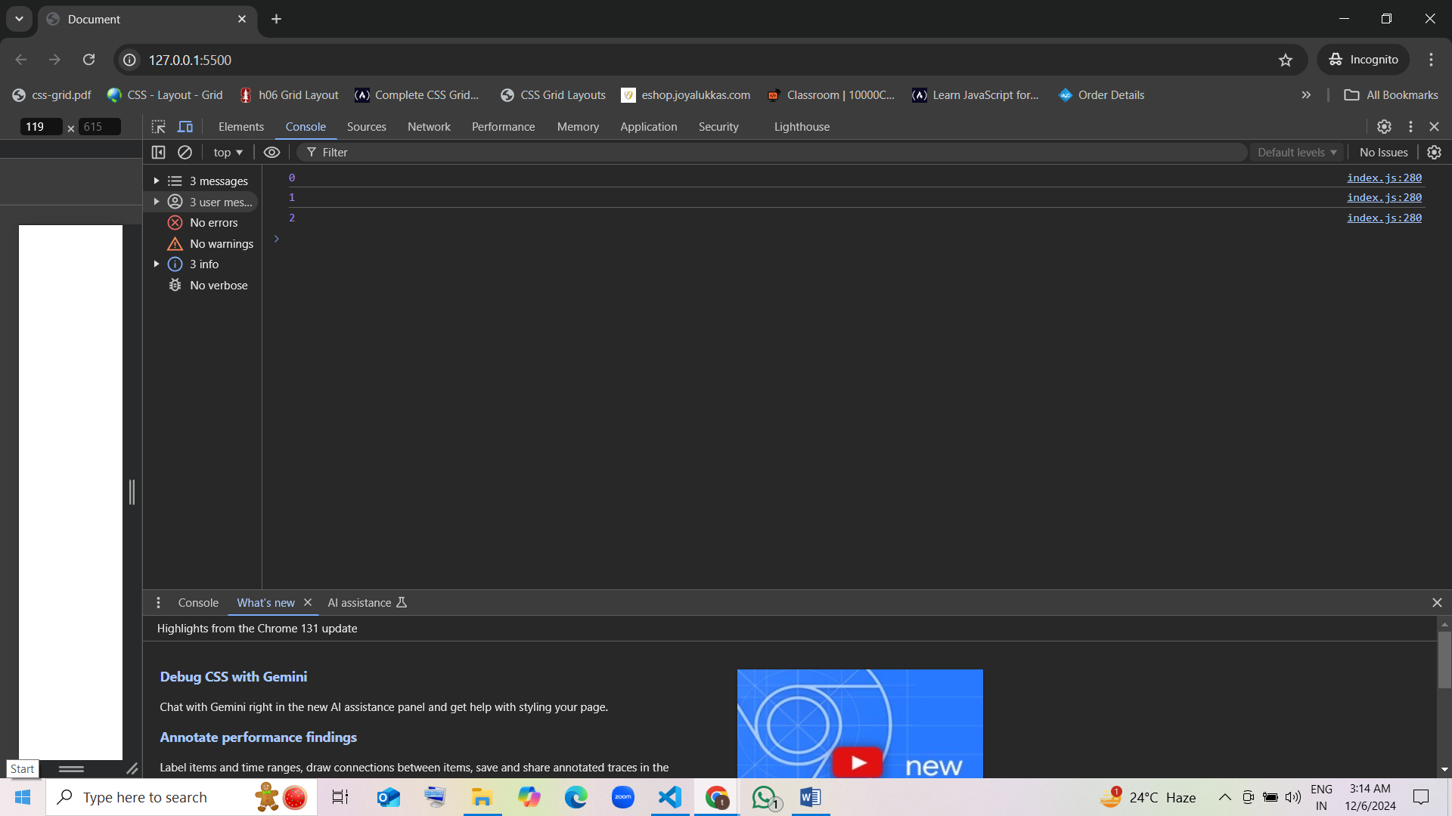

### 27. What is the output of the following code?

var i = 2;  
for (i = 0; i < 3; i++) {  
 console.log(i);  
}

1. 0 1 2 guess [correct]
2. 0 1

C) 2 3  
D) 1 2 3

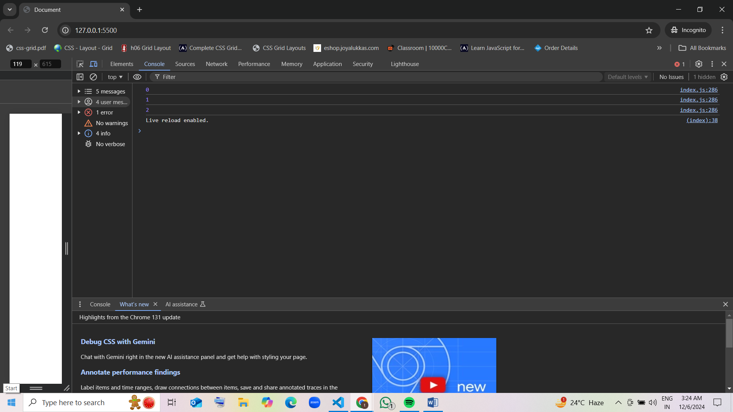

### 28. What will be printed by this code?

var i = 0; 1 2   
for (var j = 0; j < 3; j++) {  
 console.log(i); 0 1 2  
 i++;  
}

1. 0 1 2 guess [correct]
2. 1 2 3
3. 0 1 2 3
4. 0 1 1 2

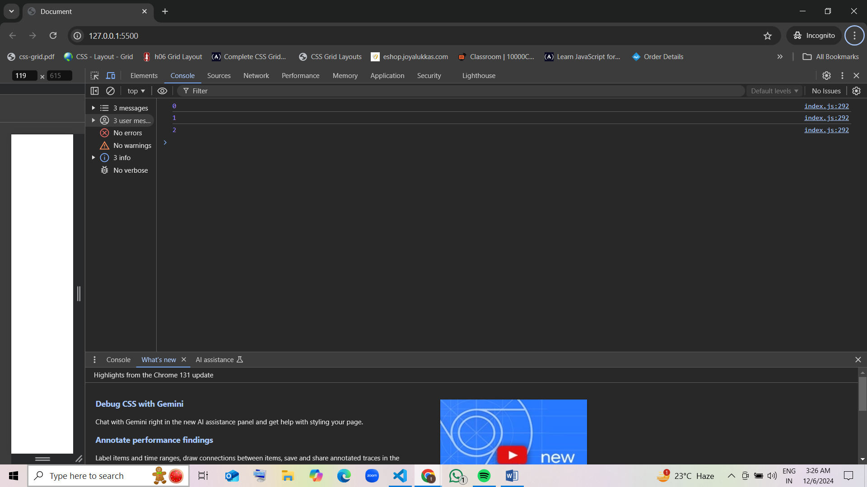

### 29. What will the following code output?

var i = 0; 2  
while (i < 2) {  
 console.log(i); 0   
 i += 2;   
}

1. 0 2
2. 0 1
3. 0 guess [correct]
4. 0 2 4

### 30. What will this code print?

var i = 0; 1 2  
do {  
 if (i === 2) break;  
 console.log(i); 0 1  
 i++;  
} while (i < 5);

1. 0 1 guess [correct]
2. 0 1 2
3. 1 2 3
4. 0 1 2 3 4

